**Shri Shamrao Patil (Yadravkar) Educational & Charitable Trust’s**

**SHARAD INSTITUTE OF TECHNOLOGY,**

**POLYTECHNIC, YADRAV.**

***DEPARTMENT OF INFORMATION TECHNOLOGY***

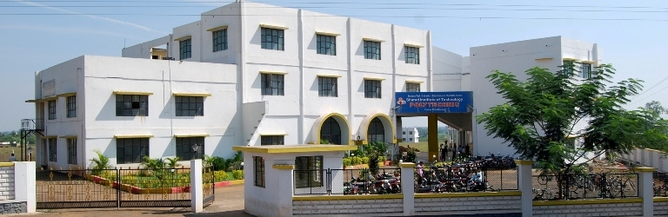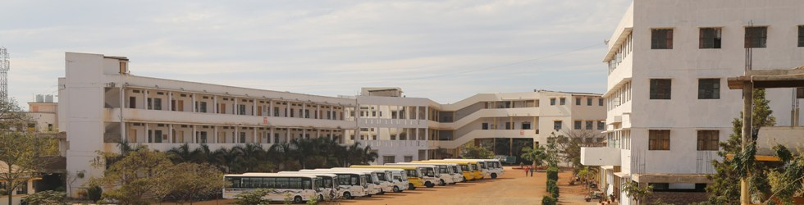

***MICRO PROJECT REPORT***

**IN**

**GUI**

**FOR**

**S.Y. 2019-20**

A

Project Report on

**“Library management System in VB.net.”**

Submitted in Partial Fulfillment of the requirements for the

**“DIPLOMA”**

in

**Information Technology**

to

**M.S.B.T.E. MUMBAI.**

**By**

**Name of candidates Roll No.**

**1)……………………………………… ………..**

**2)……………………………………… ………..**

**3)……………………………………… ………..**

**4)……………………………………… ………..**

**5)……………………………………… ………..**

**6)………………………………………. …………**

UNDER THE GUIDANCE OF

**Ms.S.D.Sawant**

**NAME OF GUIDE**

Lecturer in Information Technology.



**S.I.T.Polytechnic, Yadrav (Ichalkaranji)**

**[2018-19]**

**Shri Shamrao Patil (Yadravkar) Educational & Charitable Trust’s**

**SHARAD INSTITUTE OF TECHNOLOGY POLYTECHNIC,YADRAV (Ichalkaranji)**



**CERTIFICATE**

This is to certify that,

Name of Student Roll No.

1)………………………………………………… ………..

2)………………………………………………… ……….

3)………………………………………………… ………..

4)………………………………………………… ………..

5)………………………………………………… ………..

6)………………………………………………… ………..

have successfully completed the Project work entitled **“Library management system ”** under my supervision, in the partial fulfillment of the requirements for the **Diploma** in **information technology**, and the report submitted toM.S.B.T.E. MUMBAI. for academic year 2019-2020.

Date

Place: S.I.T.Poly. Yadrav

**Ms.S.D.Sawant Mrs.A.A.Patil**

Project Guide Head, information technology. Dept.

**ACKNOWLEDGMENT**

It is my great pleasure to present the honor and sincere gratitude to my guide Ms.S.D.Sawant Lecturer, Dept. of Information Technology. Sharad Institute of Technology Polytechnic, Yadrav helped in joining the hands in developing each and every steps of this project and for valuable guidance and constant encouragement during completion of project work. It was my privilege and pleasure to work under his valuable guidance. I am indeed gratefully to him for providing me helpful suggestions. Due to his constant encouragement and inspiration I could complete my project work.

I am very thankful to Principal, Sharad Institute of Technology, Polytechnic, Yadrav.

My grateful thanks to Mrs. A.A.Patil Information Technology Department, for their valuable guidance, support and constant encouragement.

I express thanks to my family and friends for their support and encouragement at every stage of successful completion of this project work.

My sincere thank to all those who have directly or indirectly helped me to carry out this work.

**Name of the candidate Roll No**

**1) ………………………………….. …………….. ………………………………….**

**2) …………………………………….……………. ……………………………………**

**3) ……………………………………………………. …………………………………..**

**4) …………………………………………………….. …………………………………….**

**5) ……………………………………………………… ……………………………………**